Web Radio Training in Promoting Diversity and Non-Discrimation
An exchange project developed under the MARS (Media against Racism in Sports) framework
By Tiziana Cavallo (Italy) and Adina Baya (Romania)

Project Report
The exchange project was developed by Tiziana Cavallo, who is a journalist and co-founder of the student web radio Fuori Aula Network (FAN) from the University of Verona, and Adina Baya, who also is a journalist and an assistant professor at the West University of Timisoara. The project’s output and development reflect the two participants expertise in interest both in media education and in practicing journalism. Its main purpose was to train student journalists to promote a discourse of diversity and non-discrimination when reporting about sports and other relevant issues, by offering a series of illustrative case-studies and exercises.
Description of project activities
Media education is education to media with media according to lot of scholars as Masterman (1997) Buckingham (2001) and Rivoltella (2001) in order to make the youngsters able to use them critically and consciously.
In our exchange project for MARS we decided to use radio, and especially its online version – web-radio – as a tool of media education. Traditional radio, in the FM shape, has its own language and rules but since Internet arrived radio had to change and adapt to the new concept of net and web and radio became something new and innovative.
Activities in Romania engaged some journalism students at the Faculty of Political Science, Philosophy and Communication Science at West Timisoara University in a workshop which lasted 4 days and it was divided into two activities. First activity was based on importance of sounds and listening into an environment which is more visual identity oriented and due to the fact that mostly we can see and we are not able to use in the best way our other sensed such as hearing. Thanks to the use of PowerPoint presentations and some practical exercises in the first activity the concept of soundscape was explained. Soundscape is ”every acoustic field of research, a music composition, a radio programme and an environment” and one of the most famous scholar and artist was Raymond Murray Schafer who created the World Soundscape Project at the “Simone Fraser University” in Vancouver.
Also the importance of sounds and image and their relationship has been underlined using a lot of examples of soundmaps available on the web and using some images whose description was part of some practical and engaging exercises made in the classroom. Using TED conversation of Neil Harbisson we started with students a discussion on colours and sounds and how our environment of everyday life sounds: our classroom, our home, our body etc. Then, we investigated cinema and sounds relationship explaining the strategic use of soundtrack and special effects into this field. Sounds are also important into marketing filed: radio in store and sound sponsor shopping were two interesting examples.
Sounds are, also, a strategic tool into media education experiments and contaminations between soundscaping and storytelling are nowadays an effective outcome of some media education strategies into educational and informal contexts.
What is radio and eventually what are university web radios was the further step in which we deepened into the first activity in order to arrive to define important steps to build a media education project and its contents.
The phenomenon of college radio in Italy had a strong evolution in the last six years and now is in turmoil, thanks to networking and shared projects. In the era of citizen journalism, college radios play a key role in redesigning languages and ways of doing journalism and communication. College radio bears some typical signs of pirate radios – which represent a youth sub culture 30-40 years ago - such as freedom of expression and 'simplicity' technical resources but they differ mainly the lack of political push and pure challenge. College media are now a special place where new kind of journalists can grow and become MoJo, mobile and multimedia journalist (“Raising your Mojo”, College Media Review, Spring-Summer 2010, Vol. 47). Represent and give voice and face, in fact, reference to a specific community such as academic and student and promote values such as knowledge and culture. In Italy in 2006 some actors decided to join together and give life to a cultural association, RadUni, which collects all activities and, expecially, professionals, teachers and students related to college radio and media. After this challenge, that continues also today, in 2008 some professionals created a new project: Ustation – www.ustation.it - first Italian college media network born with an Italian venture capital investment. Ustation primary objective is to enhance contents made in the Universities, supporting development through a single portal that aggregates web 2.0 media content assets. The platform hosts a live section with all the University broadcast stations and offers each user to open their profile and share audio, video, photos, create a blog, build friendships and interacting with those who are part of the community. In this site you can find all college radio and come tv projects but there are a lot of multimedia products made by young producers who give life to a big creative community in which specific topics such as discrimination and racism are in the middle of many formats. The Ustation network, supported by Raduni's aggregative actions, is an attempt to put the spotlight on national and European phenomenon to create new business and professional opportunities.
Community news, music and entertainment are ingredients which must be combined to offer real freedom of expression and creativity in content and form.
In the second activity we explored radio language elements and also into project management in order to underline the importance of strategy and some concepts as target, publics, tactics, context analysis and goals.

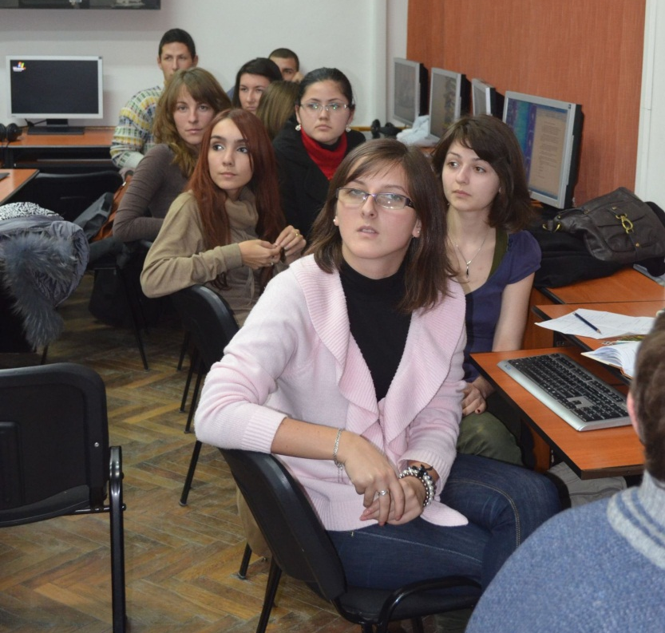
We also analysed how to do a radio format in order to teach to the students how to transform a simple idea into a radio show. Contents into a radio are split into: news, music and entertainment – which can be mixed such as in infotainment formats. The clock is the main measure of radio and its elements or ingredients are:
- Signature (theme)
- Jingle
- Promo
- Music
- Speech

We investigated all the useful and strategic steps to create a web-radio programme and we gave a model format (see attachment) the students have to fill in to it. The group activity was based on this model and students, in groups of 2 people, have to think about a radio programme on the topic of discrimination and specifically racism in sports (see attachment for one of the different outcomes).

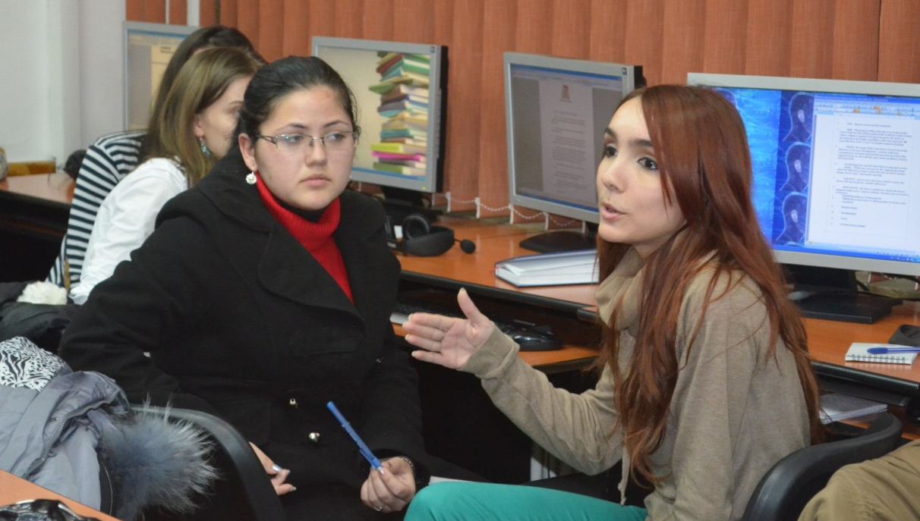
The results of this practical activity on the model is twofold:
- students’ perception of racism in sports is linked to news and not to their own experiences so they aimed to create news radio programme with a traditional schedule and not particularly innovative (VIP guests from sports fields and discussions on specific cases and issues which came from the other media such as magazines, newspapers and television)
- educational perspective is the main one, in order to educate publics to be not racialists (due probably to the fact that they are still students at first year of university).

These different radio formats on racism in sports is one of the most interesting and important outcome of this first part of the exchange because we were in front of young citizens/students who – after a brief explication of web-radio’s features in a media education perspective – created some media products which other students, already skilled into web-radio and online media and journalism at the University of Verona, already produced.
The main goals of the next two activities, developed at the University of Verona, were to familiarize students with current trends and issues relevant for the mass-media in system in Romania and to encourage them to connect these issues with specific problems of Italian media. Consequently, a particular focus was granted to some media content trends, including the coverage of topics related to ethnic minorities in the media. The purpose of these activities was to highlight the defining features of discriminatory reporting in the Romanian media, mostly in connection with covering issues related to the Romani-Gipsy community, and to analyse techniques of promoting negative stereotypes by observing particular cases.
The students were presented an overview of the defining features of the media landscape in Romania, with a focus on current issues and trends. The presentations started with a series of important facts and figures that help students situate Romanian media in the larger historical, political and sociological context of the Central and Eastern Europe region. Aspects related to demographics and family income were presented in connection to media consumption, the digital divide and media literacy.
The Romanian press market developed from a boom in the early 1990s (after the fall of communism), encouraged by state subsidies and high demand, to a moderate development throughout the mid and late 1990s. Several factors were responsible for the slowing down of the process. First of all, the inflation rate that got beyond control in the first part of the decade, reaching a peak of 256% per year in 1993. Although it slowly began to be controlled later on, by 1999 it was still high at 45%, according to the National Statistics Office. Secondly, the government-owned paper producers, printers and distributors started increasing prices at a high rate. For example, the only newsprint producer in the country, the state-controlled Letea SA, raised its prices twice in 1995, amounting to a total increase of 48.3% by the end of the year. Speculations in the media hinted toward the preferential allocation of newsprint for the outlets that were not in opposition with the state’s policies. Thirdly, the government introduced quarterly income taxes for newspapers to pay in advance, based on estimates of future income calculated by the state. Naturally, this was a further discouragement for the potential investors in the media market. It can also serve as an explanation for why, unlike in the case of other post-communist countries such as Hungary, the Czech Republic or Poland, international moguls did not see Romania as an appealing place to invest in until 1994.
The audiovisual market developed in a rather different pattern than the print media throughout the decade. Whereas the former was largely dominated by the state-owned RTV and RR until the mid 1990s and only afterwards registered an increase in market players and real competition, the latter started with an extreme escalation in the number of outlets and ended up with moderate development by the end of the decade. The reasons behind this lie in the greater centralization of the audiovisual outlets, following the communist pattern, as well as the consequent difficulties in liberalizing this market as opposed to the print one. In addition, broadcasting’s use of spectrum and the ensuing licensing procedure brought a type of technical hurdle that did not apply in the case of the print media. High sunk costs in terms of investment should also be considered in explaining why private firms were overabundant on the printed media market, but less so on the audiovisual one.
Both the print and the audiovisual market continued to grow at an accelerated pace after 2000. The state also gradually lost the control over publishing and distribution, thus intervening less and less on the market. As an indicator of investments and profitability, the advertising market rose from 225 million euro in 2004 to 320 million in 2007. This development, coupled with both the print and the audiovisual media markets getting more crowded by the end of 1990s (see EUMAP report 2005), might lead to the conclusion that the business environment became more competitive. However, a number of national and international reports noticed a different tendency.

A report developed by the Romanian Competition Council (2005) underlines concentration as being a visible market development, raising “dominance issues”. The document also advises a close watch of media mergers for the prevention of oligopolies that would restrict the access of new entrants on the market. A similar policy advice is highlighted in the EUMAP study on Television across Europe (EUMAP 2005) released at the end of 2005 and depicting Romanian TV as being “in troubled waters”. The main problems signalled by this report are, on the hand, addressing public television and its general lack of independence from the government, and on the other hand, commercial television, its insufficiently transparent ownership and its excessive concentration tendencies. A larger report issued by Freedom House (2006) on media independence also reveals comparable results. Though noticing that “political pressure on the Romanian media was considerably relieved in 2005” after the elections, the report underlines the need for more transparency in media ownership. Additionally, a radical conclusion is drawn in a study published by the “Reporters without borders” organization (2004), stressing the “berlusconization” trend noticeable especially in the local press. Offering extensive examples of small regional media “empires” owned by local government party representatives and very often funded by the preferential granting of state advertising, the report concludes that “political officials control – directly or indirectly – all but very few of the country's media”.

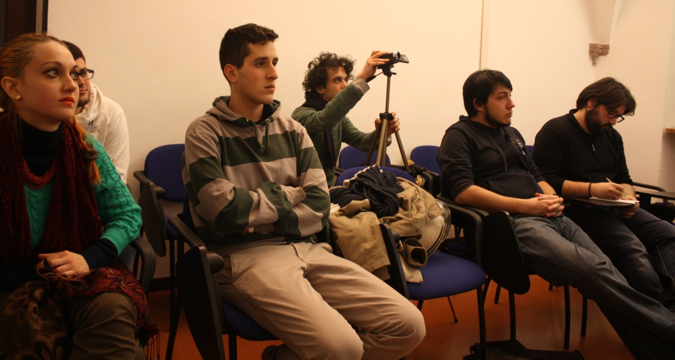

At the level of media content, some of the current trends – as established by media monitoring institutions such as ActiveWatch, which issues a yearly report on Media Freedom on http://www.activewatch.ro – include an accelerated degradation in the quality of journalistic reporting, mostly due to current economic constraints and a polarization of the media according to the political interests of its owners, especially noticeable during electoral campaigns. Additionally, a persistent issue in the post-communist Romania media is the biased and prejudiced manner in which minorities are presented in the media.
Discriminatory reporting is particularly noticeable in several articles with nationalistic and chauvinistic content, promoting intolerance especially in the case of the Romani-Gipsy minority. The promotion of negative stereotypes in the media was analysed in connection to several particular cases, including the one of Banel Nicolita, a football player from the Romanian team “Steaua”, who has repeatedly been subjected to racist remarks by football fans. The negative stereotypes in the media were found to be supported through:
- the use of terms and phrases with negative implications when describing the representatives of the minority groups and their activities;
- the overdramatization of facts and events related to the minority community, as well as the artificial increasing of the severity of certain events in a chase for sensationalism and for a reconfirmation of the negative image related to specific minority groups;
- the omission of positive reporting in connection to some minority groups, especially visible in the case of the Romani-Gipsy community;
- the tendency toward subjectivity in reporting and not presenting all sides of the story when writing about minority groups;
- the manipulation of media consumers through images that reconfirm the negative connotations attached the certain minority groups.
The feedback and conclusions of Italian students who participated at the presentation were related to unexpected similarities between Romanian and Italian media, despite their different background and history. These similarities extend both in connection to the concentration tendencies of the media market, and to the defining role of the media in establishing and reinforcing negative stereotypes regarding specific minority groups. New points and issues in the discussion on media’s role in supporting stereotypes were raised in a radio debate that took place in the studio of the campus web radio at the University of Verona: Fuori Aula Network (FAN).
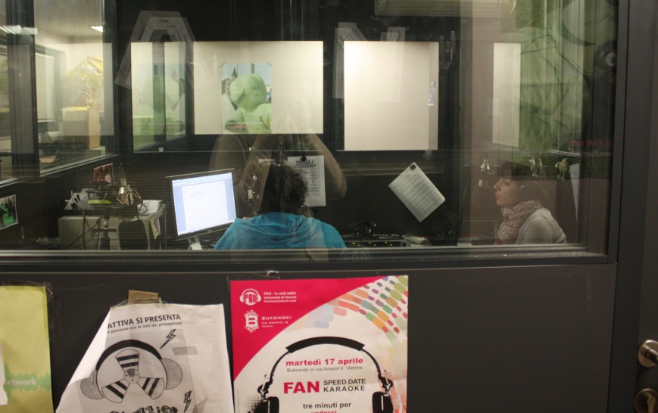
Conclusions
The series of encounters with the students, which took place both in Timisoara and Verona, focused on a review of some relevant theoretical aspects related to the functioning and the purpose of web radio, as well as on the ethical responsibilities of the journalistic profession. Their aim was to provide practical details and best practices that help students understand the social and ethical responsibilities related to practicing journalism. The project was divided into four activities: the first two took place at the West University of Timisoara, between December 3 and 7, 2012; and the last two took place at the University of Verona, between December 10 and 14, 2012. In each case, the targeted audience was represented by students specializing in Media, Communications and Journalism, and the encounters involved the participation of both exchange partners.
We believe the series of encounters with student journalists facilitated a better understanding of the concept of discriminatory reporting in the media and provided them with a consistent set of best practices meant to promote diversity and non-discrimination when reporting about minorities in sports and other relevant domains. Throughout the encounters, web radio served as a useful tool for media education, enabling students to gain an in-depth knowledge of the theme of the MARS project through hands-on examples and case studies.

